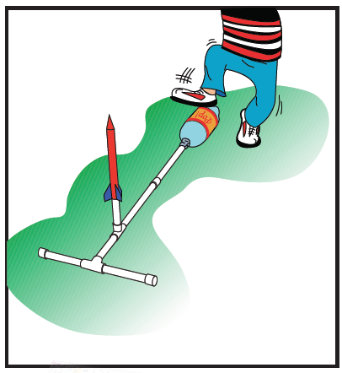 Pop! Rockets

*Adapted from*

[*NASA – Pop! Rocket Launcher Directions*](http://www.nasa.gov/pdf/295790main_Rockets_Pop_Rocket_Launcher.pdf)

*and* [*NASA – Pop! Rockets*](http://www.nasa.gov/pdf/295791main_Rockets_Pop_Rockets.pdf)

**Introduction**

Rockets are launched into space not only to take people to the moon, but to place satellites, shuttle supplies to the International Space Station (ISS), to run tests for flight designs and equipment, and other reasons.

What does it take to launch a spacecraft into space? Where does the energy come from? What role does gravity play?

**Objectives**

* SOL 6.1 – c, d, h; 6.2 – a, e;
* SOL PS.1 – b, 6, g, (h, i, j), k, m, n; PS.5; PS.6; PS.10 – a, d
* Design, construct, and launch paper rockets
* Calculate rocket height using time
* Calculate rocket speed using conservation of mechanical energy (gravitational potential energy, kinetic energy)

**Materials**

**LAUNCHER:**

Empty (and rinsed) 2-L plastic drink bottle

2 ½” PVC tee connectors

1 ½” PVC connector

2 ½” PVC caps

5’ length ½” PVC pipe

Duct Tape

Ruler

**ROCKET:**

PVC cutter

Card-stock paper/posterboard

Glue/glue stick

Cellophane tape (scotch)

Scissors

Ruler

Penny

30-cm-long pieces of ½” PVC pipe

Stopwatch

Electronic balance

**Setup**

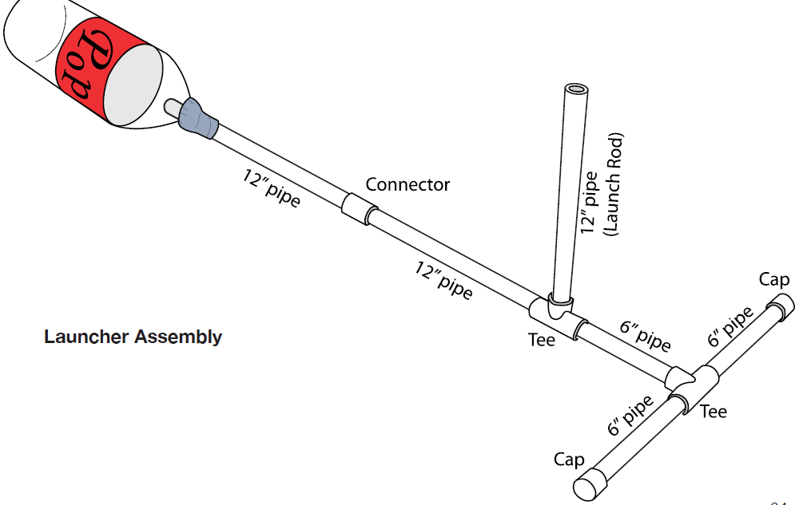

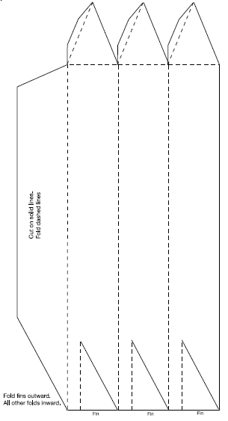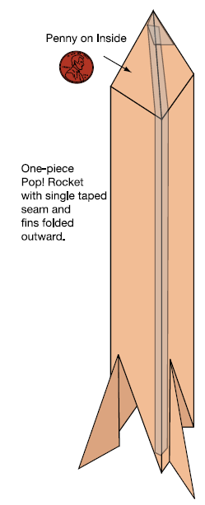



**Procedure**

PART I: Construction

**LAUNCHER**

1. Cut the PVC pipe into the following lengths:

3 pieces 12” long

3 pieces 6” long

1. Insert the end of one 12” pipe a few inches into the neck of the bottle and tape it securely with duct tape.
2. Follow the construction diagram on the previous page for assembly.

**ROCKET**

1. Reproduce the pattern on the next page onto posterboard.
2. Score the fold lines. Use a ruler and the edge of a penny to score the fold lines (place the ruler along the dashed lines and run the edge of the penny, held at an angle, across the paper to make a small groove). TAKE CARE! The groove will insure that the fold line is both accurate and straight.
3. Cut out the pattern along the solid lines.
4. Tape a penny to the inside of one of the nose cone triangles.
5. Fold the three rectangles into a triangular prism shape with the large tab inside. Tape the seam
6. Fold the triangles inward to form the nose cone. The tabs should be inside. They will provide support for taping.
7. Bend the fins outward. The rocket is ready for flight.

PART II: Experiment

1. With an electronic balance, measure the mass of your rocket. Record this value in Data Table A.
2. Stomp on the bottle to launch the rocket AND with a stopwatch, time the total time of flight. Record this value in Data Table A.
3. Divide the total time of flight by 2. Record this value in Data Table A.
4. Calculate the maximum height of the rocket using



Where *h* is the height, *g* = 9.8 m/s2 acceleration due to gravity, *t* is half the total time of flight. Show

your calculations & record value in Data Table B.

1. Calculate maximum Gravitational Potential Energy (GPE) using



Where *m* is the mass, *g* = 9.8 m/s2 acceleration due to gravity, and *h* is the height in meters. Show

your calculations & record value in Data Table B. **Energy is measured in Joules (J)

1. Calculate the launch (maximum) velocity of your rocket using



Where *v* is the launch velocity in meters per second (m/s), *g* = 9.8 m/s2 acceleration due to gravity, and *h* is the height in meters. Show your calculations & record value in Data Table B.

1. Calculate the initial (maximum) kinetic energy (KE) of your rocket using



Where *m* is the mass of your rocket in kilograms (kg), and *v* is the launch velocity in meters per second (m/s). Show your calculations & record value in Data Table B. **Energy is measured in Joules (J)

**Data Tables w Results**

**DATA TABLE A**

|  |  |
| --- | --- |
| Rocket mass (kg) |  |
| Total time of flight (s) |  |
| Half time of flight (s) |  |

**DATA TABLE B**

|  |  |  |  |
| --- | --- | --- | --- |
| Calculation: max height | *h* = | Calculation: max GPE | *GPE* = |
| Calculation: max velocity | *v* = | Calculation: max KE | *KE* = |

**Conclusions**

1. Why are fins important to the rocket shape?
2. Where in the flight was Gravitational Potential Energy the greatest? The least?
3. Where in the flight was Kinetic Energy the greatest? The least?
4. What do you notice about the Gravitational Potential Energy at the top of the flight and the Kinetic Energy at the bottom?
5. How much Gravitational Potential Energy does the rocket have at the bottom of its flight?
6. How much Kinetic Energy does the rocket have at the top of the flight?
7. Using what you know about GPE and KE, how much GPE and KE does the rocket have at half its height? Explain.