Making Waves – 1
Exploring Transverse and Compression waves on a Slinky
Part 1: What Affects the Speed of a Wave?

Introduction

In this activity, students in small groups will explore the relationship between common wave characteristics and a wave’s speed. A simple metal slinky will be used to make the waves of various types and amplitudes.

Objectives

Virginia Middle School Physical Science Standards:
- PS.6 – Transfer of energy
- PS.8 – Sound waves
  - wavelength, frequency, speed, amplitude, rarefaction, and compression;
c) the nature of compression waves; and
- PS.9 – Transverse Waves
  - wavelength, frequency, speed, amplitude, crest, and trough;

- Students will understand the difference between transverse and compression waves
- Students will understand the relationship between amplitude and wave velocity

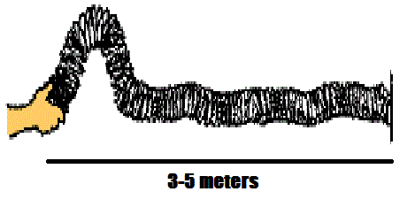
Materials, Setup

Meter stick

Slinky or Snakey, stretched to about 3-5 meters, between two group members

Timer or stopwatch

Tape or floor tiles to mark different amplitudes

Procedure, Data, Calculations and Results

1. After you have experimented with making pulses, measure the speed of each type of pulse, transverse and compression. To find the speed:
a. Measure the time it takes a pulse to travel the full length of the spring using a stopwatch.
b. Divide the length of the spring by this time.
c. Fill in your data below.

TYPE OF WAVE | Time for Pulse to Travel the length of Spring (s) | Average Time (s) | Speed of Wave  = Length (m)  Avg. Time(s)

Transverse
Compression

How does the speed of the transverse pulse compare to the speed of the compression pulse?

2. Now check to see if the amplitude of the wave affects its speed. Using a transverse pulse, select 3 different amplitudes and calculate the average speed for each. Fill in your data below.

Amplitude | Time for Pulse to Travel the length of Spring (s) | Average Time (s) | Speed of Wave  = Length (m)  Avg. Time(s)

Large
Medium
Small

Is there a relationship between the amplitude of the pulse and the speed of the wave?

Conclusions

- Make a general statement about what does and does not affect the speed of a wave:

