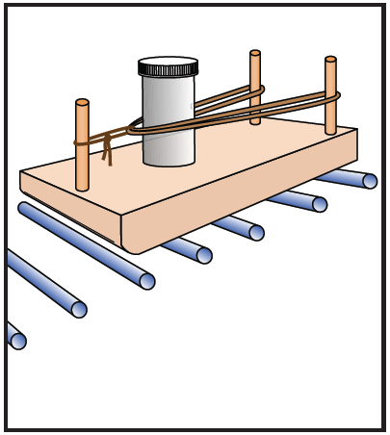
Newton Cars
Adapted from NASA’s Newton Cars

Introduction

Sir Isaac Newton’s 3 Laws of Motion:

- Inertia. An object at rest will remain at rest and an object in motion will remain in motion in a straight line at a constant speed unless acted on by an outside force.
- Σ F = ma. (Sum of all forces is equal to the mass times the acceleration). An object’s acceleration is directly proportional to the sum of all forces on an object, and inversely proportional to the object’s mass.
- Equal and Opposite Forces. For any force exerted on object A by object B, there is an equal and opposite force exerted on object B by object A.

Objectives

- SOL 6.1 c,e,g-i,k; 6.2 a
- SOL PS.1 b-d,g-i,k-n; PS.10

- Investigate the relationship between mass, acceleration, and force as described in Newton’s Laws of Motion
- Describe mechanical and non-mechanical energy conversions

Materials

ACTIVITY
Newton Car
String
2 rubber bands
Medicine bottle
Hot wheels cars
Velcro/masking tape
Meter stick
Metric balance
Scissors
Washers
Eye protection
NEWTON CAR
1”x 3”x 8” board
3 dowel rod pieces (2.5” long, ¼” diameter)
Wood glue

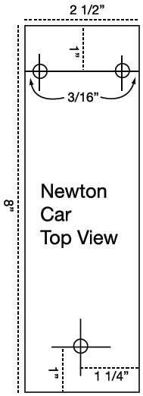
Procedure & Setup
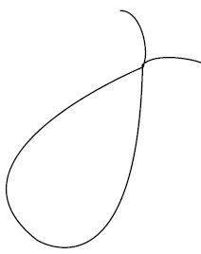
- Drill three ¼” holes 3/8” deep for the dowels. (may also use screws for posts)
- Glue the dowels into the holes.

- Tie six string loops approximately this size:
***for best results, make these as uniform as possible!

- Fill the plastic bottle with small weights (washers) provided by your teacher.

- Measure the mass of the filled bottle and record the amount on your data sheet for test 1.

- Set up your Newton Car as shown below . Affix the Newton Car to the Hot Wheels cars with Velcro or tape. ***for best results, ensure the Newton Car is as level as possible, and the Hot Wheels cars are aimed in the exact same direction.
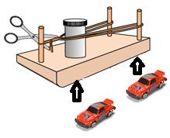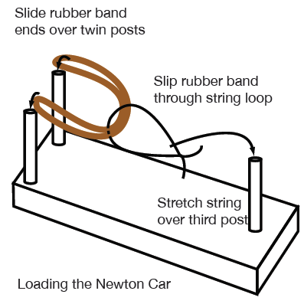

- Slip the ends of the rubber band over the two posts (see above). Pull the string back to stretch the rubber band, and slip the loop over the third post to hold the loop.

- Using the scissors, cut the string. Quickly move the scissors out of the way!

- Measure how far the Newton Car moved and record the distance on the data sheet.

- Repeat the experiment using 2 rubber bands. Record your data.

- Put different weights in the bottle. Measure its mass. Record the mass and repeat the experiment with one and two rubber bands. Record your data.

- Alter weights in the bottle once more. Record the mass and repeat the experiment with one and two rubber bands. Record your data.

Data and Results

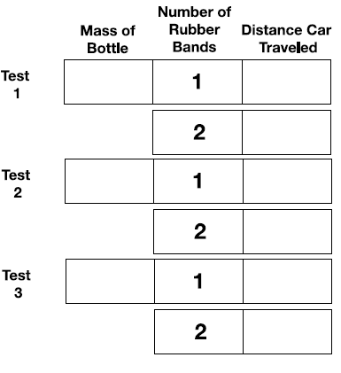

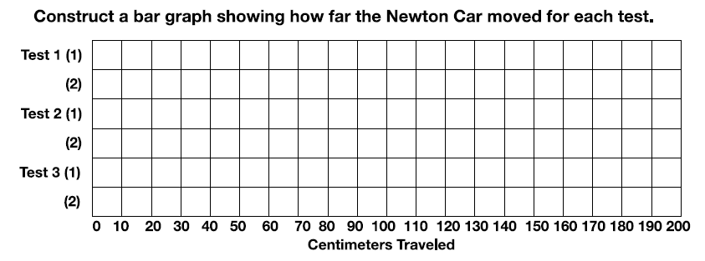

Conclusions

- Did the number of rubber bands affect how far the Newton Car moved? Describe what happened.
- Did the mass of the bottle affect how far the Newton Car moved? Describe what happened.
- Write a short statement explaining the relationship between the amount of mass in the bottle, the number of rubber bands used, and the distance the Newton Car traveled. How are these quantities related to the variables in Newton’s Second Law Σ F = ma ?
- In this activity, where is Newton’s First Law illustrated?
- In this activity, where is Newton’s Third Law illustrated?
- EXTENSION. In terms of energy, describe all energy conversions in temporal order from before the string is cut, until the Car comes to rest. (Kinetic Energy, Potential Energy, Heat Energy)

