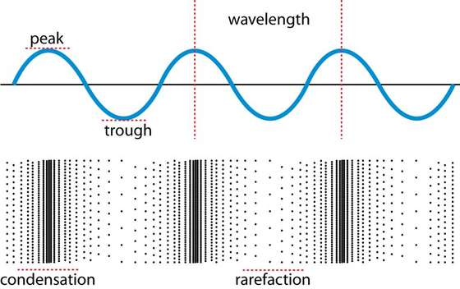
Speed of Sound Lab
Use resonance to calculate the speed of sound in air.

Introduction

In this activity, students in small groups will calculate the speed of sound using their knowledge of resonance, wavelength, frequency and longitudinal waves.

Objectives

Virginia Middle School Physical Science Standards:
- PS.8 – Sound waves
  - wavelength, frequency, speed, amplitude, rarefaction, and compression;
c) the nature of compression waves; and
- PS.9 – Transverse Waves
  - wavelength, frequency, speed, amplitude, crest, and trough;

- Students will recognize resonance by sound and theory.
- Students will be able to calculate velocity using wavelength and frequency.

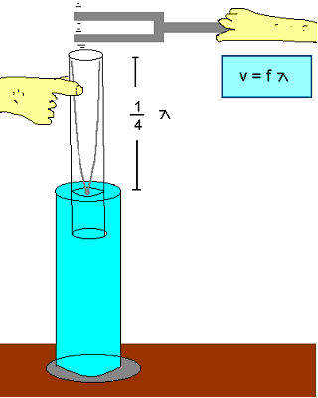
Materials, Setup

Meter stick

Bucket full of water

Plastic resonant tube

Set of tuning forks

Physicslessons.com

Procedure, Data, Calculations and Results

1. Determine the wavelength and the wave speed of sound for different resonant frequencies and lengths.
Tuning Fork Frequency | Length of pipe above the water when the sound is loudest. | Wavelength  (multiply length x 4) | Speed of Wave  v= λ*f

2. Average the calculated speeds and compare to the known value of 340 m/s.

